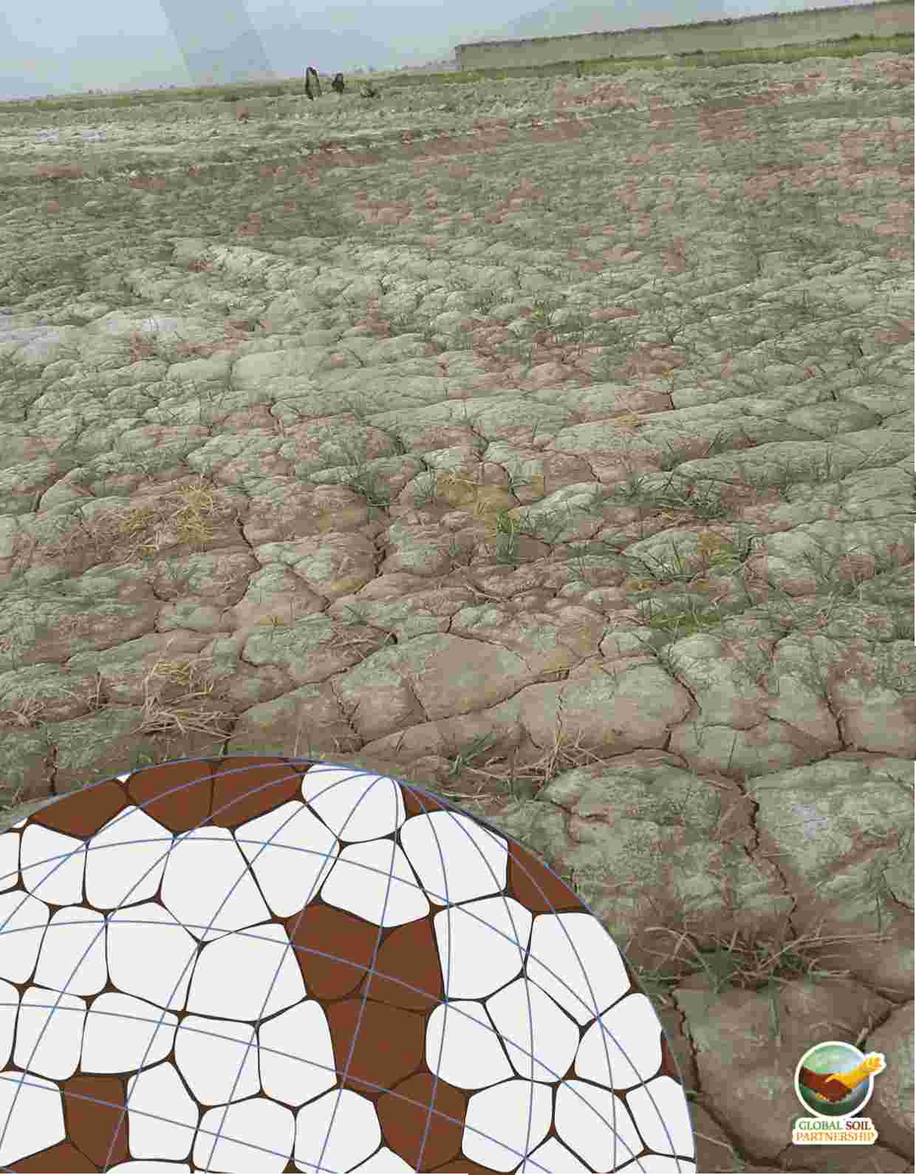

Food and Agriculture Organization of the United Nations



**Global Soil Salinity Map**

**(GSS map)**

**Lesson 3 : Spatial modelling of**

**soil indicators (properties)**

**related to salt problems**

Disclaimer and copyright

**Recommended citation:**

Omuto, C.T., Vargas, R., Viatkin, K., Yigini, Y., 2020. Capacity building for national assessment of salt- affected soils: Lesson 3 – Spatial modelling of soil indicators (properties) related to salt problems. Rome

The designations employed and the presentation of material in this information product do not imply the expression of any opinion whatsoever on the part of the Food and Agriculture Organization of the United Nations (FAO) concerning the legal or development status of any country, territory, city or area or of its authorities, or concerning the delimitation of its frontiers or boundaries. The mention of specific companies or products of manufacturers, whether or not these have been patented, does not imply that these have been endorsed or recommended by FAO in preference to others of a similar nature that are not mentioned.

The views expressed in this information product are those of the author(s) and do not necessarily reflect the views or policies of FAO.

Capacity building for national assessment of salt-affected soils: Lesson 3 – spatial modelling of soil indicators (properties) related to salt problems

Capacity building program is part of the country-driven framework for updating national and global level information of salt-affected soils. It aims at mobilizing country-level resources and expertise to assess the status of salt-affected soils and build foundation for future monitoring and management of these soils. The program is a systematic procedure to strengthen national capacities as well as harmonize global approaches for building information of salt-affected soils. This document illustrates the third lesson of the capacity-building program and focuses on spatial modelling of soil properties related to salt problems.

FOOD AND AGRICULTURE ORGANIZATION OF THE UNITED NATIONS ROME, 2020

Summary

This Lesson is the third step of the capacity-building program, which is designed to build national capacities as well as harmonize procedures for developing information of salt-affected soils at the national and global levels. The overall goal of this Lesion is to support participants in developing spatial gridded maps of soil properties (indicators) related to salt-affected soils at the national level. At the end of the lesson, the participants are expected to have technical capacity in generating spatial information on soil indicators of salt-affected soils in their countries.

Summary outputs of gridded soil properties for establishing national information of salt-affected soils

|  |  |
| --- | --- |
| **Item Description Format** | |
| **Gridded soil property maps** | Topsoil (0-30 cm) EC, pH, and ESP geoTiff raster files |
| Subsoil (30-100 cm) EC, pH and ESP geoTiff raster file |
| **Gridded uncertainty maps** | Topsoil (0-30 cm) EC, pH, and ESP geoTiff raster files |
| Subsoil (30-100 cm) EC, pH and ESP geoTiff raster file |
| **Textfile** | Topsoil (0-30 cm) accuracy indices (ME, RMSE, r2, Spreadsheet  NSE) |
| Subsoil (0-30 cm) accuracy indices (ME, RMSE, r2, Spreadsheet  NSE) |
|  |  |

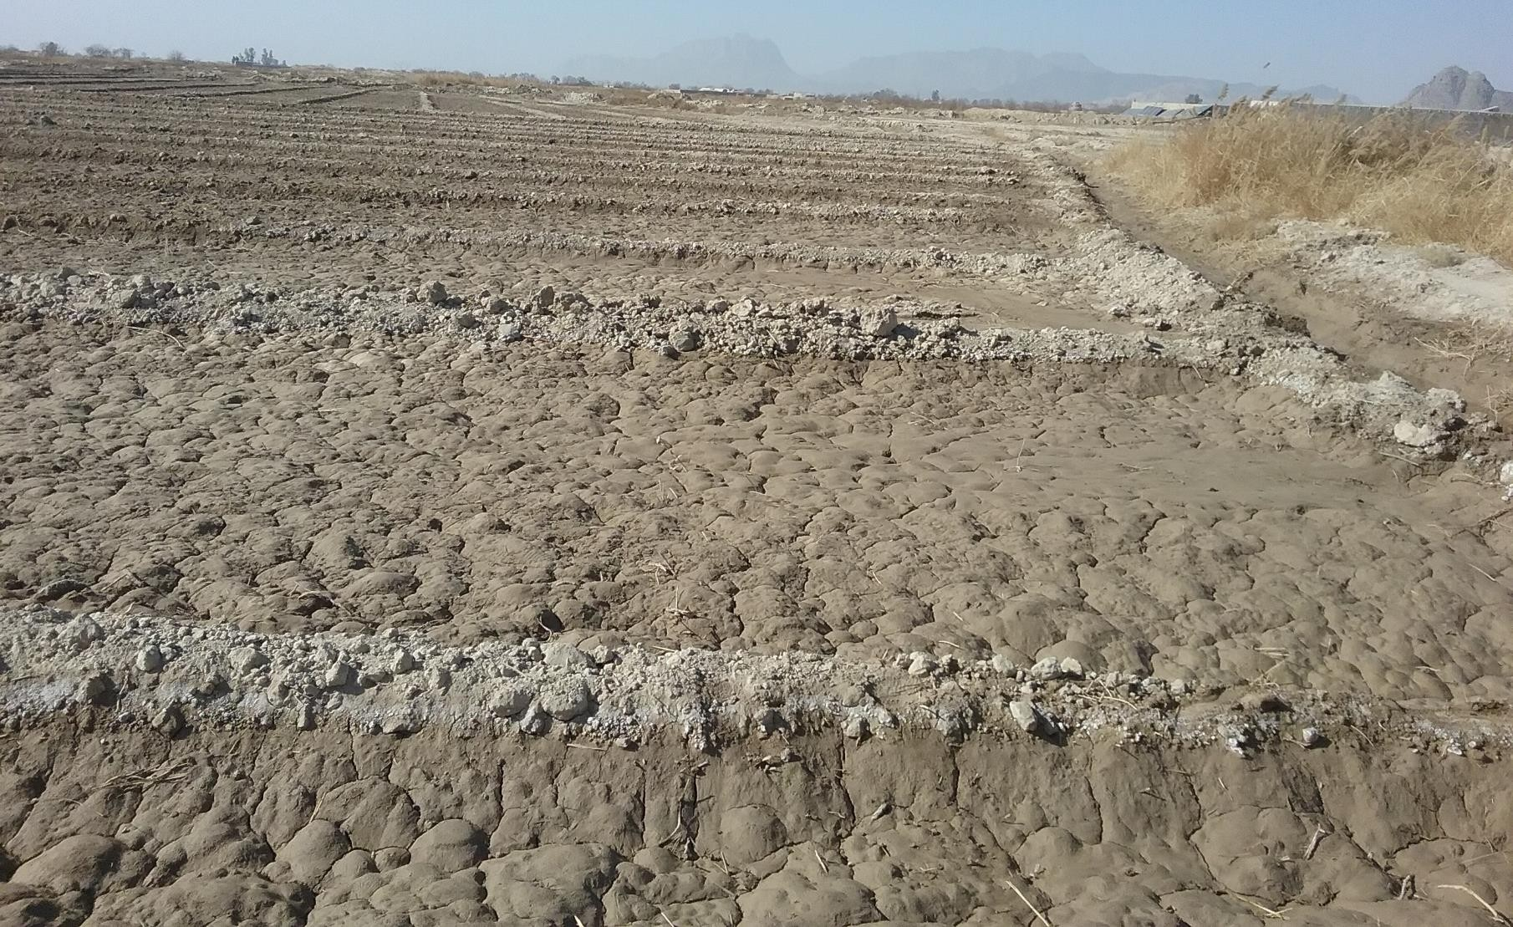

Table of Contents

Disclaimer and copyright ......................................................................................................................... i Summary ................................................................................................................................................. ii List of Figures ......................................................................................................................................... iii List of Tables .......................................................................................................................................... iii

1 Introduction .................................................................................................................................... 1

1.1 Overview ................................................................................................................................. 1

1.2 Objective ................................................................................................................................. 1

1.3 Expected outcomes................................................................................................................. 1

2 Requirements for assessing salt-affected soils ............................................................................... 1

2.1 Data requirements .................................................................................................................. 1

2.2 Software requirements ........................................................................................................... 2

3 Resources ........................................................................................................................................ 3

4 Activities.......................................................................................................................................... 3

4.1 Loading data and R packages .................................................................................................. 3

4.2 Check and harmonize statistical distribution of GIS layers ..................................................... 6

4.3 Harmonization of input soil data ............................................................................................ 9

4.4 Spatial modelling of indicators ............................................................................................. 10

5 Outputs ......................................................................................................................................... 15

List of Figures

Figure 1: Location of test case soil in North State of Sudan ................................................................... 2

Figure 2: Creating working folder ........................................................................................................... 3

Figure 3: Loading files from R Project ..................................................................................................... 4

Figure 4: Setting working directory for test data.................................................................................... 4

Figure 5: Empirical statistical distribution of image indices ................................................................... 7

Figure 6: Correlation of image indices and scree plot of their principal component ............................. 8

Figure 7: Example depth harmonization for ECse .................................................................................... 9

Figure 8: Graphical plot of frequency distribution with prediction limits at 95% confidence interval 12

Figure 9: Graphical plot of predicted versus measured EC................................................................... 13

Figure 10: Representativeness of validation (sample points) EC ranges in prediction map (feature map)

.............................................................................................................................................................. 14

Figure 11: Spatial prediction width at 95% confidence interval and overlay of validation points ....... 15

List of Tables

Table 1: Organization of test case data .................................................................................................. 1

Table 2: MODIS remote sensing images ................................................................................................. 2

1 Introduction

1.1 Overview

Many methods exist in the literature for mapping salt-affected soils. They include methods based on soil-type maps, remote sensing images, expert opinion, and digital soil mapping (DSM) of soil properties related to salt problems. The approach using DSM of soil indicators has the potential to quantify uncertainty and mapping accuracy besides developing spatial information (maps) of soil properties related to salt problems. This Lesson focuses on spatial modelling of soil indicator of salt problems in the soil. The Lesson also outlines steps for assessing accuracy and uncertainties associated with spatial modelling of soil indicators of salt-affected soils. It targets national experts with knowledge of and access to data on the indicators of salt-affected soils in their countries. Its outputs are expected to contribute to the development of national and global spatial information of salt- affected soils.

1.2 Objective

The overall objective of this Lesson is to spatially model soil indicators of salt problems using digital soil mapping approach.

1.3 Expected outcomes

By the end of this Lesson, the participants are expected to be able to:

i. Spatially model soil properties related to salt-affected soils using digital soil mapping approach ii. Assess soil mapping accuracy and uncertainty

iii. Produce gridded maps of soil indicators (properties) related to salt problems in the soil

2 Requirements for assessing salt-affected soils

2.1 Data requirements

This Lesson uses test data, which was collected from the North State of Sudan (Figure 1). The data comprise

• Soil data (electrical conductivity (EC), pH and Exchangeable Sodium Percent (ESP))

• Spatial covariates such as mean annual rainfall amounts, land cover, geology, hydrogeology, MODIS remote sensing images, altitude (DEM)

The soil data is arranged as shown in Table 1.

Table 1: Organization of test case data

|  |  |
| --- | --- |
| sample Pits Longitude Latitude Upper Lower Horizon EC pH ESP | |
| 5 | 2 29.81 20.62 0 10 1.000 1.900 8.600 10.000 |
| 6 | 2 29.81 20.62 10 30 2.000 0.700 7.800 5.000 |
| 7 | 2 29.81 20.62 30 100 3.000 |
| 8 | 3 31.57 17.15 0 35 1.000 0.900 7.600 5.000 |
| 9 | 3 31.57 17.15 35 60 2.000 0.400 7.800 2.000 |
| 10 | 3 31.57 17.15 60 100 3.000 0.400 7.900 2.000 |

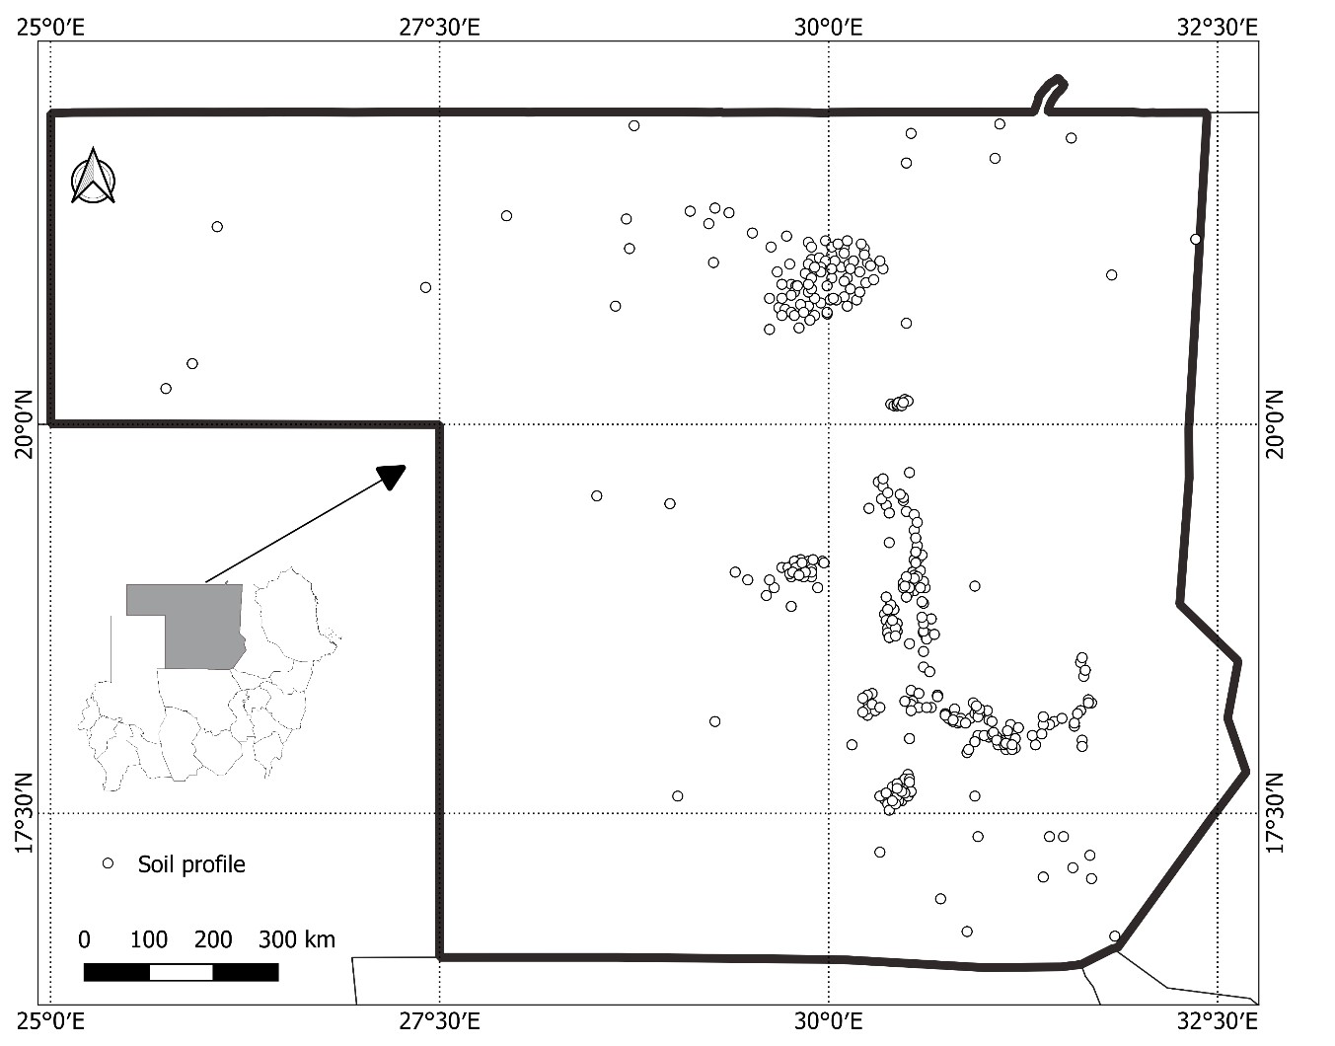

Figure 1: Location of test case soil in North State of Sudan

Other GIS files are raster files at a spatial resolution of 1 km and projected as WGS 84 (UTM 36N). Remote sensing images are corrected MODIS reflectance bands (Table 2).

Table 2: MODIS remote sensing images

|  |  |
| --- | --- |
| **Image Spectral bands** | |
| **MODIS MOD009GA V6** | Band 3 Blue: 0.459-0.479 µm |
| Band 4 Green: 0.545-0.565 µm |
| Band 1 Red: 0.62-0.67 µm |
| Band 2 NIR: 0.841-0.876 µm |
| Band 6 SWIR1: 1.628-1.652 µm |
| Band 7 SWIR2: 2.105-2.13 µm |

The test-case data (soil.RData, predictors.RData) have been stored ([here)](https://drive.google.com/drive/folders/1q_vmlh9HrKcWA7NEiZVRM4oXxbocsir8) in R datafile format. Soil.RData is the calibration soil dataset while predictors.RData is a stack of GIS raster file.

2.2 Software requirements

The latest version of the software should have been installed (from Lesson 2)

i. R ([https://www.r-project.org/)](https://www.r-project.org/)

ii. QGIS ([https://qgis.org/en/site/forusers/download.html)](https://qgis.org/en/site/forusers/download.html)

iii. RStudio ([https://rstudio.com/products/rstudio/download/#download)](https://rstudio.com/products/rstudio/download/#download)

iv. ILWIS ([https://www.itc.nl/ilwis/download/ilwis33/)](https://www.itc.nl/ilwis/download/ilwis33/)

v. Spreadsheet software (Excel, Access) and document software (Word, Notepad)

R packages are also needed for spatial modelling with R: *soilassessment, sp, foreign, rgdal, car, carData, spacetime, gstat, automap, randomForest, e1071, caret, raster, soiltexture, GSIF, aqp, plyr, Hmisc, corrplot, factoextra, spup, purrr, lattice, ncf, ranger*. They should be downloaded and installed alongside R software.

3 Resources

The following resources are useful for implementing the activities during data collection:

• References

o Technical guidelines and manual for mapping salt-affected soils ([GSP-](mailto:GSP-Secretariat@fao.org) [Secretariat@fao.org)](mailto:GSP-Secretariat@fao.org)

o Country guidelines and specifications for global mapping of salt-affected soils

4 Activities

4.1 Loading data and R packages

*#Step 1: Load the data and set working directory*

Create a folder in C and call it Salinity (C:/Salinity) by right-click on New Folder in C using windows explorer (Figure 2). Unzip the downloaded zipped file (DSM_saltaffected.zip) in C/Salinity

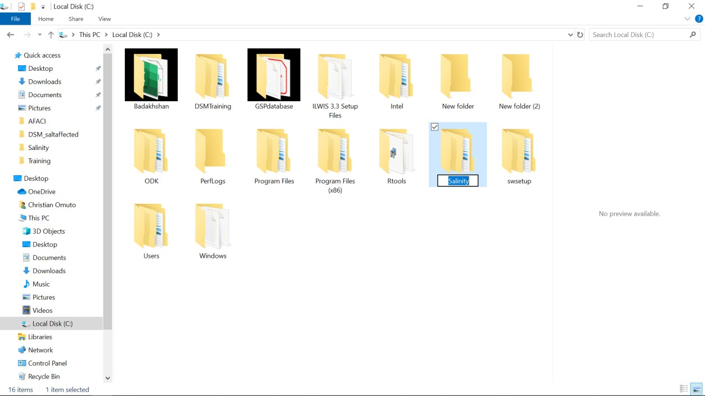

Figure 2: Creating working folder

In RStudio and at the top-right corner, click on project and scroll down to “Open Project”. Navigate to C:/Salinity/DSM_saltaffected to locate “DSM_salaffected.Rproj” file. Choose it to load the project. In the bottom-right corner, choose *File* button (the first button in a set of File, Plots, Packages, Help, Viewer). This will reveal a set of files in the DSM_saltaffected.Rproj (Figure 3). Double click the files (one at a time) and accept the dialogue that follows (Digital_mapping_of_saltaffected_soils.R, predictors.RData, soil.RData, soilvalid.RData)

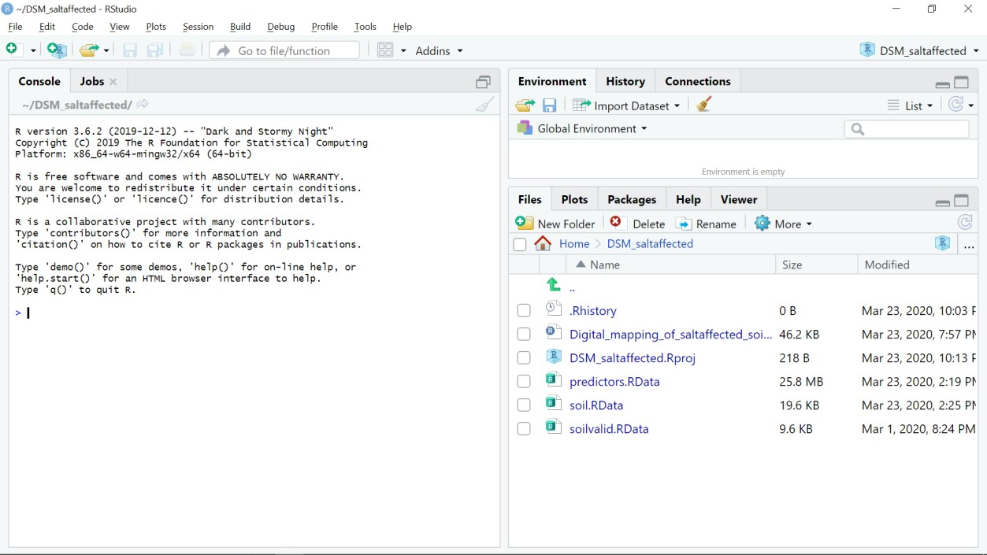

Figure 3: Loading files from R Project

At the top of the bottom-right panel, click the (gear) icon labelled *“More”*, and scroll to choose “*Set as Working Directory”* (Figure 4). This step sets the working directory of the test data.

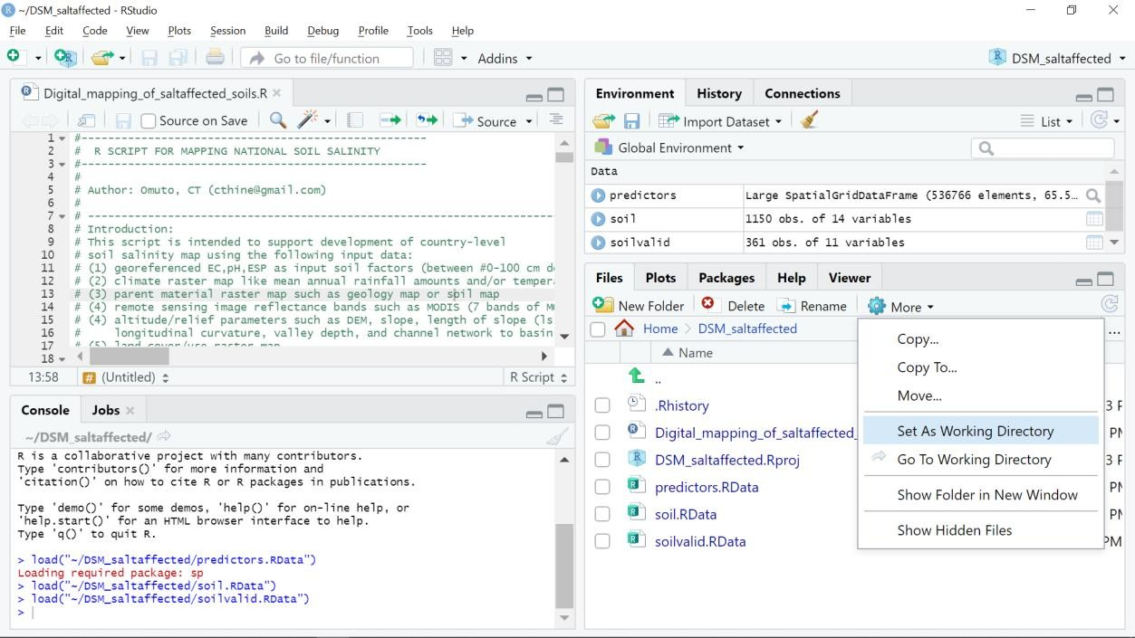

Figure 4: Setting working directory for test data

*#Load R packages*

R packages contain the functions for digitals soil mapping of soil properties. If the packages were not installed during Lesson 2, then they should be first installed before loading the libraries.

> install.packages(c("raster", "sp", "rgdal", "car", "carData", "dplyr", "spacetime ", "gstat", "automap", "randomForest", "fitdistrplus", "e1071", "caret", "soilasses sment", "soiltexture", "GSIF", "aqp", "plyr", "Hmisc", "corrplot", "factoextra", "s pup", "purrr", "lattice", "ncf", "npsurv", "lsei", "qrnn", "nnet", "mda", "RColorBr ewer", "vcd", "readxls","maptools","neuralnet","psych","ggrepel", "plotly"))

In case there is error in installation,

1. Check if internet connectivity is adequate

2. If internet connectivity is OK, then note the packages which are not installing and install them manually

3. click packages in the lower bottom panel

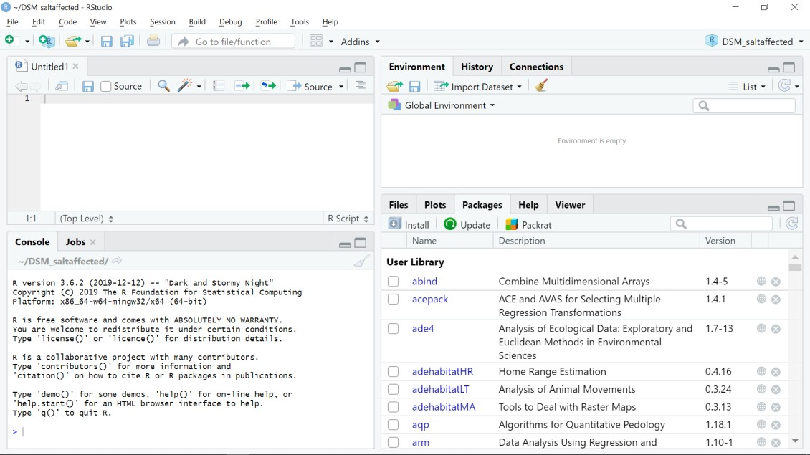

4. Click *Install* icon below the *Packages* button in (3) above. A window will pop-up for installing the package. At this point your internet connectivity should be active

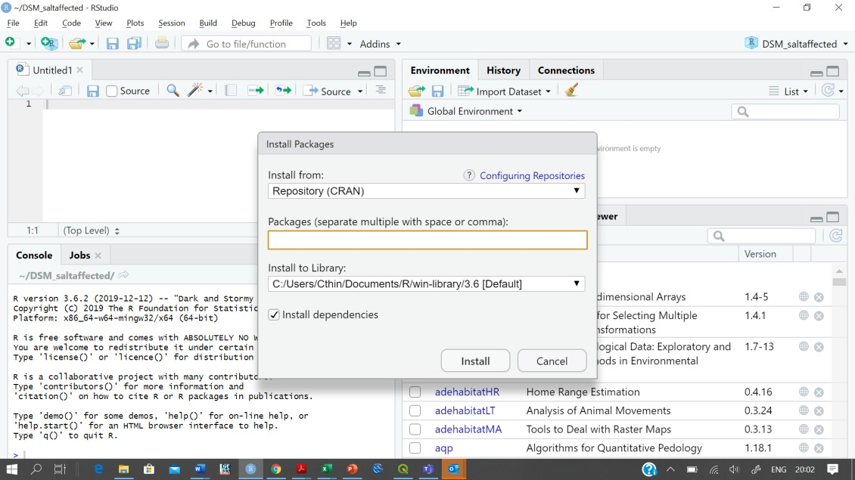

5. Type the name of the package in the space below *Packages (separate multiple with space or comma): (NB: you can also c*opy and paste each bullet below into the same space)

a. raster, sp, rgdal, car, carData, dplyr, spacetime, gstat, automap, randomForest, fitdistrplus, e1071,

b. caret, soilassessment, soiltexture, GSIF, aqp, plyr, Hmisc, corrplot, factoextra, spup,

purrr, lattice

c. ncf, npsurv, lsei, qrnn, nnet, mda, RColorBrewer, vcd, readxls, maptools, neuralnet, psych, ggrepel, plotly

The libraries should be loaded after installing the packaged

>library(sp);library(foreign);library(rgdal);library(car);library(carData);library(

maptools)

>library(spacetime);library(gstat);library(automap);library(randomForest);library(f itdistrplus);

>library(e1071);library(caret);library(raster);library(soilassessment);library(soil texture);

>library(GSIF);library(aqp);library(plyr);library(Hmisc);library(corrplot);library(

factoextra)

>library(spup);library(purrr);library(lattice);library(ncf);library(npsurv);library

(lsei);

>library(nnet);library(class);library(mda);library(RColorBrewer);library(vcd);libra ry(grid);

>library(neuralnet);library(readxl);library(psych);library(qrnn);library(dplyr)

4.2 Check and harmonize statistical distribution of GIS layers

Before checking and harmonizing statistical distribution of GIS layers, it is important to check and remove pixels with data (NA pixels).

*#Check and remove NA*

> summary(predictors)

Object of class SpatialGridDataFrame

Coordinates:

min max x -356126.8 465873.2 y 1825343.5 2478343.5

Is projected: TRUE

proj4string :

[+proj=utm +zone=36 +datum=WGS84 +units=m +no_defs +ellps=WGS84 +towgs84=0,0,0] Grid attributes:

cellcentre.offset cellsize cells.dim x -355626.8 1000 822 y 1825843.5 1000 653

Data attributes:

…..

|  |  |  |
| --- | --- | --- |
| lcover geology | pgeology | rain swir1 |
| Min. : 2.0 Min. : 1.00 | Min. : 0.9977 | Min. : 0.1938 Min. :0.01449 |
| 1st Qu.:178.0 1st Qu.:31.00 | 1st Qu.: 3.0000 | 1st Qu.: 2.0000 1st Qu.:0.58141 |
| Median :178.0 Median :32.00 | Median : 3.0000 | Median : 4.0000 Median :0.65651 |
| Mean :177.4 Mean :47.55 | Mean : 3.8039 | Mean : 7.2899 Mean :0.63076 |
| 3rd Qu.:178.0 3rd Qu.:66.00 | 3rd Qu.: 3.0000 | 3rd Qu.: 7.8400 3rd Qu.:0.70472 |
| Max. :188.0 Max. :88.00 | Max. :10.0000 | Max. :70.5665 Max. :0.93891 |

…..

NAs will be shown in the layers where they occur. They should be first investigated where/why they occur. If they are predominantly outside the study area and occurred dude to GIS raster clipping, then they can be removed, for example, by replacing them with the mean of the data.

> predictors$slope=ifelse(is.na(predictors$slope),mean(!is.na(predictors$slope)),pr edictors$slope)

*#Derive the remote sensing indices*

Derive the remote sensing indices of salt problems and attach them in the *predicters* stack of GIS

layers. The indices are derived using the function *imageIndices* in the *soilassessment* library (Omuto,

20201).

> predictors$SI1=imageIndices(predictors$BBlue,predictors$BGreen,predictors$BRed,pr edictors$BIRed,predictors$swir1,predictors$swir2,"SI1");summary(predictors$SI1)

Min. 1st Qu. Median Mean 3rd Qu. Max.

0.04471 0.31981 0.35173 0.34386 0.37887 0.54641

> predictors$SI2=imageIndices(predictors$BBlue,predictors$BGreen,predictors$BRed,pr edictors$BIRed,predictors$swir1,predictors$swir2,"SI2");summary(predictors$SI2)

Min. 1st Qu. Median Mean 3rd Qu. Max.

0.0389 0.2297 0.2540 0.2490 0.2749 0.4108

…….

> predictors$BI=imageIndices(predictors$BBlue,predictors$BGreen,predictors$BRed,pre dictors$BIRed,predictors$swir1,predictors$swir2,"BI");summary(predictors$BI)

Min. 1st Qu. Median Mean 3rd Qu. Max.

0.07189 0.73497 0.83005 0.80074 0.89241 1.22795

Any NAs arising from the calculation of the image indices should be remove where necessary.

*#Check for skewness using empirical histogram distribution*

> hist[(predictors@data[](mailto:predictors@data),27:29]) # Figure 5.2

> summary(predictors$SI6)

# Min. 1st Qu. Median Mean 3rd Qu. Max.

# 0.003647 0.940943 1.129692 1.068303 1.232106 1.663694

> predictors$BI=sqrt(predictors$BI)

> hist(predictors$BI)

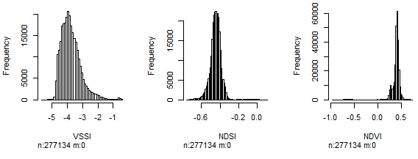

Figure 5: Empirical statistical distribution of image indices

For the moment, square-root or log transformation can be tested for data normalization.

> hist[(predictors@data[](mailto:predictors@data),"rain"])

> summary(predictors$rain)

Min. 1st Qu. Median Mean 3rd Qu. Max.

0.1938 2.0000 4.0000 7.2899 7.8400 70.5665

> predictors$rain=log(predictors$rain)

1Omuto, CT. 2020. soilassessment: Assessment Models for Agriculture Soil Conditions and Crop

Suitability. <https://cran.r-project.org/web/packages/soilassessment/index.html>

*#Perform PCA and select the first PCs accounting for over 95% of the image indices’ variation*

After normalizing the image indices, they are selected and converted into data-frame to enable determination of correlation and principal component analysis. Afterwards, the selected PCs are converted back to the raster stack.

*# Extract the image layers*

> predict[ers=predictors@data](mailto:predictors@data)[,c("SI1","SI2","SI3","SI4","SI5","SI6","SAVI","VSSI"," NDSI","NDVI","SR","CRSI", "BI")]

> soil.cor=cor(predicters)

> corrplot(soil.cor,method="number",number.cex = 0.8) # Figure 6a

> pca<-prcomp(predicters[], scale=TRUE)

> fviz_eig(pca) # Figure 6b

The correlation plot (Figure 6a) shows the correlation between image indices. For example, SI1 and SI2 have Pearson correlation index equal to 86%. PCA examines these correlations and determines the principal axes where data are highly correlated. These axes are also known as principal component (or dimensions in Figure 6b). Figure 6 is important in guiding the choice of PCs to represent the entire (13) layers of image indices.

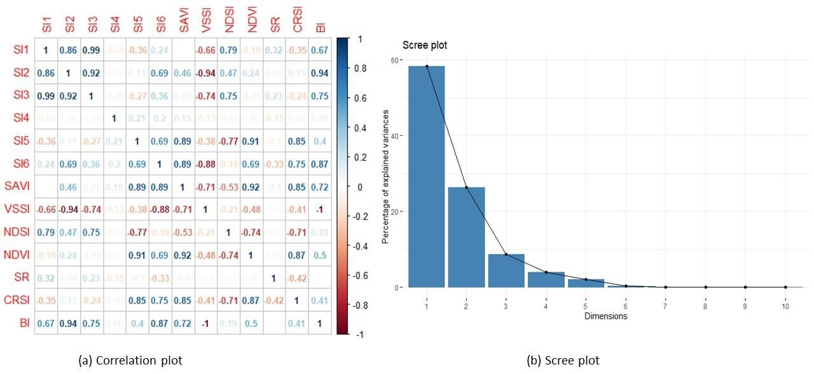

Figure 6: Correlation of image indices and scree plot of their principal component

In Figure 6b, cumulative sum of the first 5 PCs (Dimensions) add to up to more than 95% explained variation in the overall 13 layers of the image indices. Hence, the first 4 PCs can adequately represent the 13 image indices. This approach can be used on any set of image indices to select the appropriate number of PCs to reduce the data bulk.

*# Return the selected PCs to the raster stack to complete the harmonization process*

> Pred.pcs<-predict(pca,predicters[])

[> predictors@data$PCA1=](mailto:predictors@data$PCA1)Pred.pcs[,1]

[> predictors@data$PCA2=](mailto:predictors@data$PCA2)Pred.pcs[,2]

[> predictors@data$PCA3=](mailto:predictors@data$PCA3)Pred.pcs[,3]

[> predictors@data$PCA4](mailto:predictors@data$PCA4)=Pred.pcs[,4]

4.3 Harmonization of input soil data

*# Harmonize input indicator measurements to those for saturated soil paste extract*

Many methods can be used to determine EC. They include (1) the use of saturated soil paste extract, (2) using other extracts, (3) using pedotransfer models from other soil properties, or (4) electromagnetic induction. Harmonization seeks to standardize methods 2 to 4 to equivalent values in method 1, since popular classification schemes use values obtained by method 1. The test case data was determined using saturated soil paste extract. Hence, it will not require EC harmonization. Omuto et al. (2020)2 outlines steps for harmonizing EC for the cases 2 to 4.

Soil depth harmonization aims at developing soil information for uniform depth throughout the soil data. This harmonization is achieved by using the depth-integrating spline approach (Bishop et al.,

19993). The tool for implementing the approach is contained in the *GSIF* package (Hengl, 2019)4.

> lon=soil1$Longitude

> lat=soil1$Latitude

> id=soil1$Pits

> top=soil1$Upper

> bottom=soil1$Lower

> horizon=soil1$Horizon

> ECdp=soil1$EC

> prof1=join(data.frame(id,top,bottom, ECdp, horizon),data.frame(id,lon,lat),type=" inner")

Joining by: id

> depths(prof1)=id~top+bottom

Warning message:

converting IDs from factor to character

> site(prof1)=~lon+lat

> coordinates(prof1) = ~lon+lat

> proj4string(prof1)=CRS("+proj=longlat +datum=WGS84 +no_defs")

> depth.s = mpspline(prof1, var.name= "ECdp", lam=0.8,d = t(c(0,30,100,150))) Fitting mass preserving splines per profile...

|================================================================| 100%

> plot(prof1, color= "ECdp", name="horizon",color.palette = rev(brewer.pal(8, 'Acce nt')),par=c(cex.lab=2.0)) #Figure 7

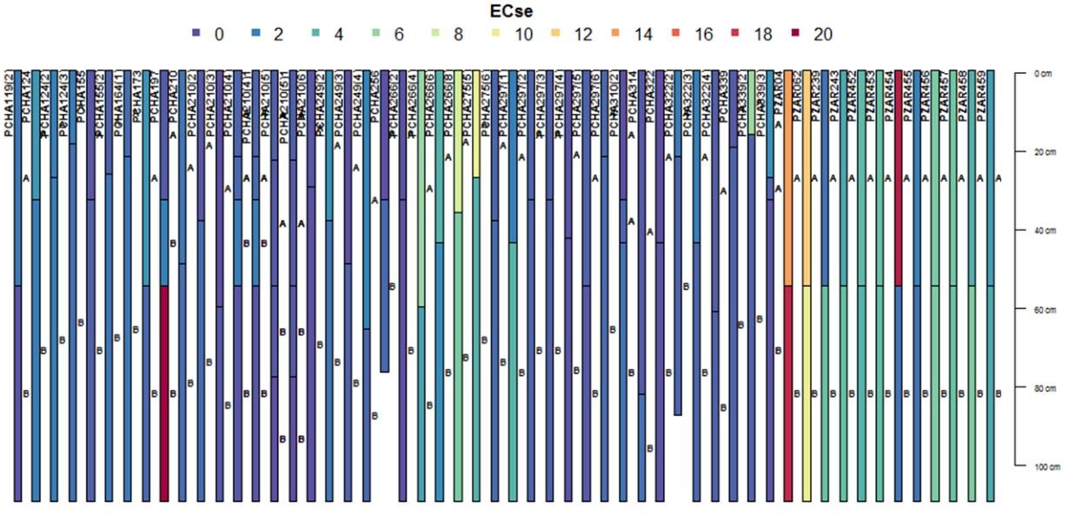

Figure 7: Example depth harmonization for ECse

2Omuto CT, Vargas RR, El Mobarak, AM, Mohamed N, Viatkin K, Yigini Y. (Eds). 2020. Global mapping of salt-affected soils: A

technical guideline and cookbook. Rome

3Bishop, T.F.A, McBratney, A.B., Laslett, G.M., 1999. Modelling soil attribute depth functions with equal-area quadratic

smoothing splines. Geoderma, 91(1-2), 27-45

4 Hengl T. 2019. GSIF: Global Soil Information Facilities. <https://cran.r-project.org/web/packages/GSIF/index.html>

*# Extract the depth-harmonized soil data and re-project*

> soilhrmdepths=data.frame(depth.s$idcol, depth.s$var.std, check.names = TRUE)

> soil2=merge(soil1,soilhrmdepths,by=intersect(names(soil1),names(soilhrmdepths)),b y.x="Pits",by.y="depth.s.idcol",all=TRUE)

> coordinates(soil2)=~Longitude+Latitude

> proj4string(soil2)=CRS("+proj=longlat +datum=WGS84")#Attach CRS to the data

*#Harmonize CRS and ensure use of the correct +proj and +zone for the study area*

> soil1=spTransform(soil2,CRS("+proj=utm +zone=36 +ellps=WGS84 +units=m +no_defs"))

> soil1=soil2

> hist(soil1$EC)

> soil1=subset(soil1,!is.na(soil1$EC))

*#Harmonization of statistical distribution*

This harmonization is done to transform the frequency distribution to normal distribution. Frequency transformation to normal distribution is optional for spatial modelling algorithms. If it’s chosen, then the empirical distribution is first established through histogram analysis and transformation implemented if the distribution is found to be skewed. *hist* function is used to extract and plot the histogram. Box-Cox (1964) transformation is preferred. The following scripts illustrate the steps for transforming statistical distribution. Summary distribution is first obtained to establish if there are zeros, *Nas*, or negative values. It is desirable to remove them before implementing Box-Cox transformation.

> summary(soil1$X0.30.cm)

Min. 1st Qu. Median Mean 3rd Qu. Max.

0.0007 0.6291 1.8709 6.6812 5.3121 154.2463

> soil1$dummy=(soil1$EC)# (you may) add "+0.001" if minimum X0.30.cm is zero

> hist(soil1$dummy, main="Frequency distribution (before transformation)", xlab="Ha

rmonized EC (dS/m)")

> soil1$Tran=(soil1$dummy^(as.numeric(car::powerTransform(soil1$dummy, family ="bcP ower")["lambda"]))-1)/(as.numeric(car::powerTransform(soil1$dummy, family ="bcPower ")["lambda"]))

4.4 Spatial modelling of indicators

Spatial modelling of indicators of salt-affected soils is based on the digital soil mapping (DSM) concept. In this concept, a relationship is built between the soil indicators of salt problems and spatial predictors (GIS layers of drivers and indicators of salt problems and soil forming factors). This approach enables quantification of:

1. Spatial information of indicators of salt-affected soils (EC, pH, ESP) and different soil depths

2. Mapping uncertainties and accuracy

3. Spatial information of classes and intensity of salt problems

Popular models often used to represent *f* are linear, random-forest, support-vector machine, mixed- effects, regression kriging, etc. The *soilassessment* package provides *regmodelSuit* function for guiding the choice of the appropriate model for mapping soil variables. It tests different models and returns the top nine models using RMSE, ME, NSE and r2. Lowest root mean-square error (RMSE), highest r2, lowest mean error (ME), highest Nash-Sutcliff coefficient of efficiency (NSE) are then used as the guiding criteria for choosing the suitable model. An initial step for spatial modelling is to build the model in a calibration dataset and then testing the model using an independent dataset. This calls for the establishment of calibration and validation datasets. These datasets should have well aligned soil properties (indicators) and spatial predictors at each georeferenced sampling point. Pixel value

extraction of GIS layers (predictors) using point data (soil1) is a suitable method for developing either the calibration or validation datasets.

*# First check for similarity in coordinate reference system – crs and then extract the predictors*

> crs(predictors); crs(soil1) CRS arguments:

+proj=utm +zone=36 +datum=WGS84 +units=m +no_defs +ellps=WGS84 +towgs84=0,0,0

CRS arguments:

+proj=utm +zone=36 +datum=WGS84 +units=m +no_defs +ellps=WGS84 +towgs84=0,0,0

It’s important to ensure that the CRS for predictors and soil database are the same before starting

pixel extraction

*#Then extract the pixel values for all predictors into the soildata dataframe*

> {predictors.ov=over(soil1, predictors)

+ soil1$dem=predictors.ov$dem

+ soil1$slope=predictors.ov$slope

+ soil1$cnbl=predictors.ov$cnbl

+ soil1$ls=predictors.ov$ls

+ soil1$valley=predictors.ov$valley

+ soil1$loncurve=predictors.ov$loncurve

+ soil1$lcover=predictors.ov$lcover

+ soil1$rain=predictors.ov$rain

+ soil1$pgeology=predictors.ov$pgeology

+ soil1$geology=predictors.ov$geology

+ soil1$PCA1=predictors.ov$PCA1

+ soil1$PCA2=predictors.ov$PCA2

+ soil1$PCA3=predictors.ov$PCA3

+ soil1$PCA4=predictors.ov$PCA4

+ }

*#Step 2-2: Establish suitable DSM model*

> soil1=subset(soil1,!is.na(soil1$dem))

> soil11a[=soil1@data](mailto:soil1@data)[,c("Tran","dem","slope","ls","cnbl","loncurve","valley","rain"

,"lcover","pgeology","geology","PCA1","PCA2","PCA3","PCA4")]

> regmodelSuit(soil11a,Tran,dem,geology,pgeology,slope,rain,loncurve,cnbl,valley,lc over,ls,PCA1,PCA2,PCA3, PCA4)

|========================================================================| 100%

|  |  |  |  |  |
| --- | --- | --- | --- | --- |
|  | ME | RMSE | R2 | NSE |
| Linear | 1.37034834 | 1.8129133 | 0.1320264 | -4.45424486 |
| RandomForest | 0.24614749 | 0.4291176 | 0.9623631 | 0.99707891 |
| SVM | 1.34745209 | 1.8212570 | 0.1357457 | -4.44014767 |
| BayesianGLM | 1.36669809 | 1.8051662 | 0.1399516 | -4.55079779 |
| BaggedCART | 0.88676091 | 1.1705841 | 0.7018074 | 0.44302759 |
| Cubist | 0.07851255 | 0.2744213 | 0.9753726 | 1.00000000 |
| CART | 1.40147986 | 1.8274332 | 0.1320797 | -4.56273851 |
| Ranger | 0.26852953 | 0.4205875 | 0.9655103 | 0.99702690 |
| QuantRandForest | 0.04923343 | 0.2855093 | 0.9761419 | 1.00000000 |
| QuantNeuralNT | 1.16162791 | 1.7075411 | 0.2582558 | 0.07778314 |

The above results depict the *quantum regression random forest* and *cubist* models as suitable for modelling the 0-30cm ECse using the given spatial predictors in the case-study test data.

Statistical model building and testing strategies recommend independent datasets for model building and for model testing. These datasets should ideally be sampled with focus for model building and testing. In the absence of independently sampled dataset for either model building (calibration) or testing (validation), data-splitting strategy is often used. Data-splitting strategy randomly (or stratified randomly) splits the data into two parts. One part is held as calibration and the other as validation. The validation dataset is used for accuracy assessment. The indices for reporting modelling accuracy include RMSE, ME, r2, NSE, and a graphical plot of the modelled versus harmonized values. Data- splitting may be arbitrarily chosen according to or depending on the data-size.

*#Step 2-3: Model building and testing*

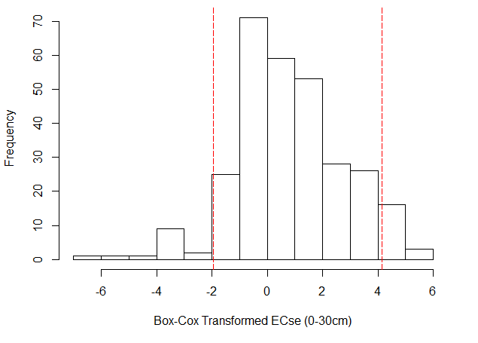

> {soil4=as.data.frame(soil1)

+ bound <- floor((nrow(soil4)/4)*3)

+ soil3 <- soil4[sample(nrow(soil4)), ]

+ df.traina <- soil3[1:bound, ]

+ df.testa <- soil3[(bound+1):nrow(soil3), ]}

> rf.ec=train(Tran~(slope+rain+loncurve+ls+cnbl+valley+lcover+dem+PCA1+PCA2+PCA3+PC A4+PCA5), data = df.traina, method = "qrf", trControl=trainControl( method = "cv"

,number=5,returnResamp = "all",savePredictions = TRUE, search = "random",verboseIte r = FALSE))

# Show the prediction interval

> df.testa$Strain=predict(rf.ec,newdata=df.testa)

> hist(df.testa$Strain,xlab="Box-Cox Transformed ECse (0-30cm)", main=NULL)

> abline(v = quantile(df.testa$Strain, probs = c(0.05, 0.95)),lty = 5, col = "red")

Figure 8: Graphical plot of frequency distribution with prediction limits at 95% confidence interval

Prediction limits on the Box-Cox transformed values at 95% confidence interval are given in Figure 8, which shows the interval around the mean of 0.77 as [-2, 4.1].

*#Accuracy assessment*

> cor(df.testa$Strain,df.testa$dummy)^2 [1] 0.9950319

> {plot(df.testa$Strain~df.testa$dummy, xlab="Measured ECse",ylab="Modelled ECse", main="Accuracy assessment on hold-out samples")

+ abline(a=0,b=1,lty=20, col="blue")} # Figure 9

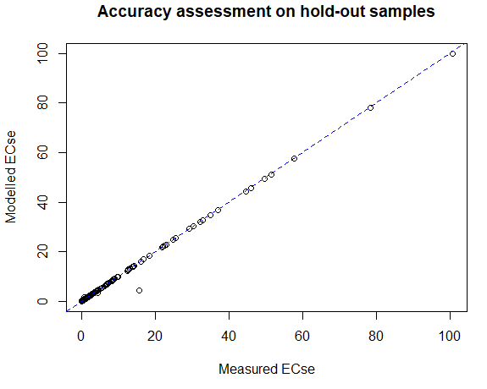

Figure 9: Graphical plot of predicted versus measured EC

> Bias=mean(df.testa$Strain-df.testa$dummy,na.rm=TRUE)

> RMSE=sqrt(sum(df.testa$Strain-df.testa$dummy,na.rm=TRUE)^2/length((df.testa$Strai n-df.testa$dummy)))

> Rsquared=cor(df.testa$Strain,df.testa$dummy)^2

> NSE=1-sum(df.testa$Strain-df.testa$dummy,na.rm=TRUE)^2/sum((df.testa$Strain-mean(

df.testa$dummy,na.rm=TRUE))^2,na.rm=TRUE)

> statia=data.frame(Bias,RMSE,Rsquared,NSE);View(statia)

> write.csv(statia,file = "EC0_30_validmodel_stats.csv")

> statia

Bias RMSE Rsquared NSE

1 -0.1019564 1.751158 0.9950319 0.982046

*#Use the developed model to predict the map of EC*

> lmbda1=(as.numeric(powerTransform(soil1$dummy, family ="bcPower")["lambda"]))

> predictors$ECte=predicta(rf.ec,predictors)

> coordinates(df.testa)=~Longitude+Latitude

> proj4string(df.testa)=CRS("+proj=utm +zone=36 +datum=WGS84 +units=m +no_defs +ell ps=WGS84 +towgs84=0,0,0") # Make sure to use correct CRS

> predicters.ov1=over(df.testa, predictors)

> df.testa$Predre=predicters.ov1$ECse

> cor(df.testa$dummy,df.testa$Predre)^2 [1] 0.9978655

*#Compare the spatial prediction and validation dataset*

> featureRep(predictors["ECse"],df.testa) #Figure 5.10

Two-sample Kolmogorov-Smirnov test data: dist.histbb$left and dist.histbb$right

D = 0.52174, p-value = 0.003819

alternative hypothesis: two-sided

> summary(predictors$ECse);summary(df.testa$dummy)

Min. 1st Qu. Median Mean 3rd Qu. Max.

0.00007 0.48810 1.17487 1.51685 1.61781 112.74435

Min. 1st Qu. Median Mean 3rd Qu. Max.

0.00048 0.59755 1.71126 6.60388 5.05220 113.50941

Figure 10: Representativeness of validation (sample points) EC ranges in prediction map (feature map)

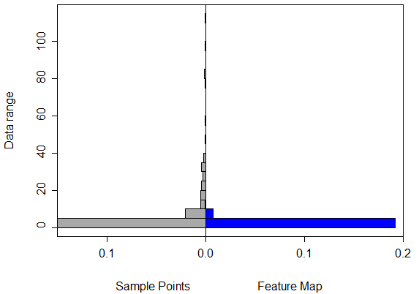

The feature representation shows how well the range of measured EC (validation EC) are contained in the prediction map. In the case-study sample, high EC (>40 dS/m) are poorly captured in the prediction map. The x-axis shows the frequency (probability density) of occurrence of data (EC) values in y-axis. Poor representation of the high (EC > 40) implies model uncertainty for high EC values. This will be further investigated when uncertainties are produced.

*#Export the output*

writeGDAL(predictors["ECse"], drivername = "GTiff", "Top0_30ECse.tif")

*#Uncertainty assessment*

> soil6a=soil1[,c("Tran")]

> predictors6a=predictors[c("dem","slope","cnbl","lcover","loncurve","rain","pgeolo gy","geology","ls","valley","PCA1","PCA2","PCA3","PCA4","PCA5")]

> pred_uncerta=predUncertain(soil6a,predictors6a,3,95,"qrandomforest")

|======================================================================| 100%

> spplot(pred_uncerta, "pred_width", scales = list(draw = TRUE),col.regions=heat.co lors(20,rev = TRUE)) + spplot(df.testa,"dummy",pch=3,cex=0.4) #Figure 11

*#Step 2-7: Exporting the uncertainty maps*

> EC0_30_uncertain=(pred_uncerta$pred_width*lmbda1+1)^(1/lmbda1)

> writeRaster(EC0_30_uncertain, filename="EC0_30_uncertain.tif",format="GTiff")

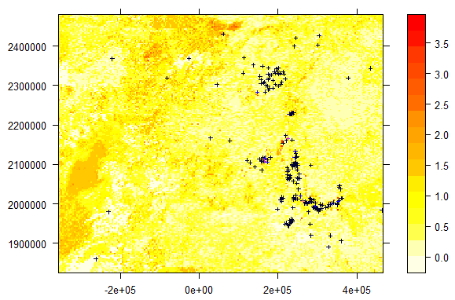

Figure 11: Spatial prediction width at 95% confidence interval and overlay of validation points

The above steps for spatial modelling of EC should be repeated for pH, ESP for 30-100 cm soil depths.

5 Outputs

Each participant is expected to produce the following at the end of this lesson:

1. GeoTiff raster maps of soil indicators of salt-affected soils (EC, pH, anf ESP) for 0-30 cm and

30-100 cm (all together 6 raster maps)

2. GeoTiff raster maps of uncertainty assessment for each soil property (EC, pH, and ESP) for 0-

30 cm and 30-100 cm (all together 6 raster maps)

3. Text file of accuracy assessment for each soil property (EC, pH, and ESP) for 0-30 cm and 30-

100 cm (all together 6 raster maps)

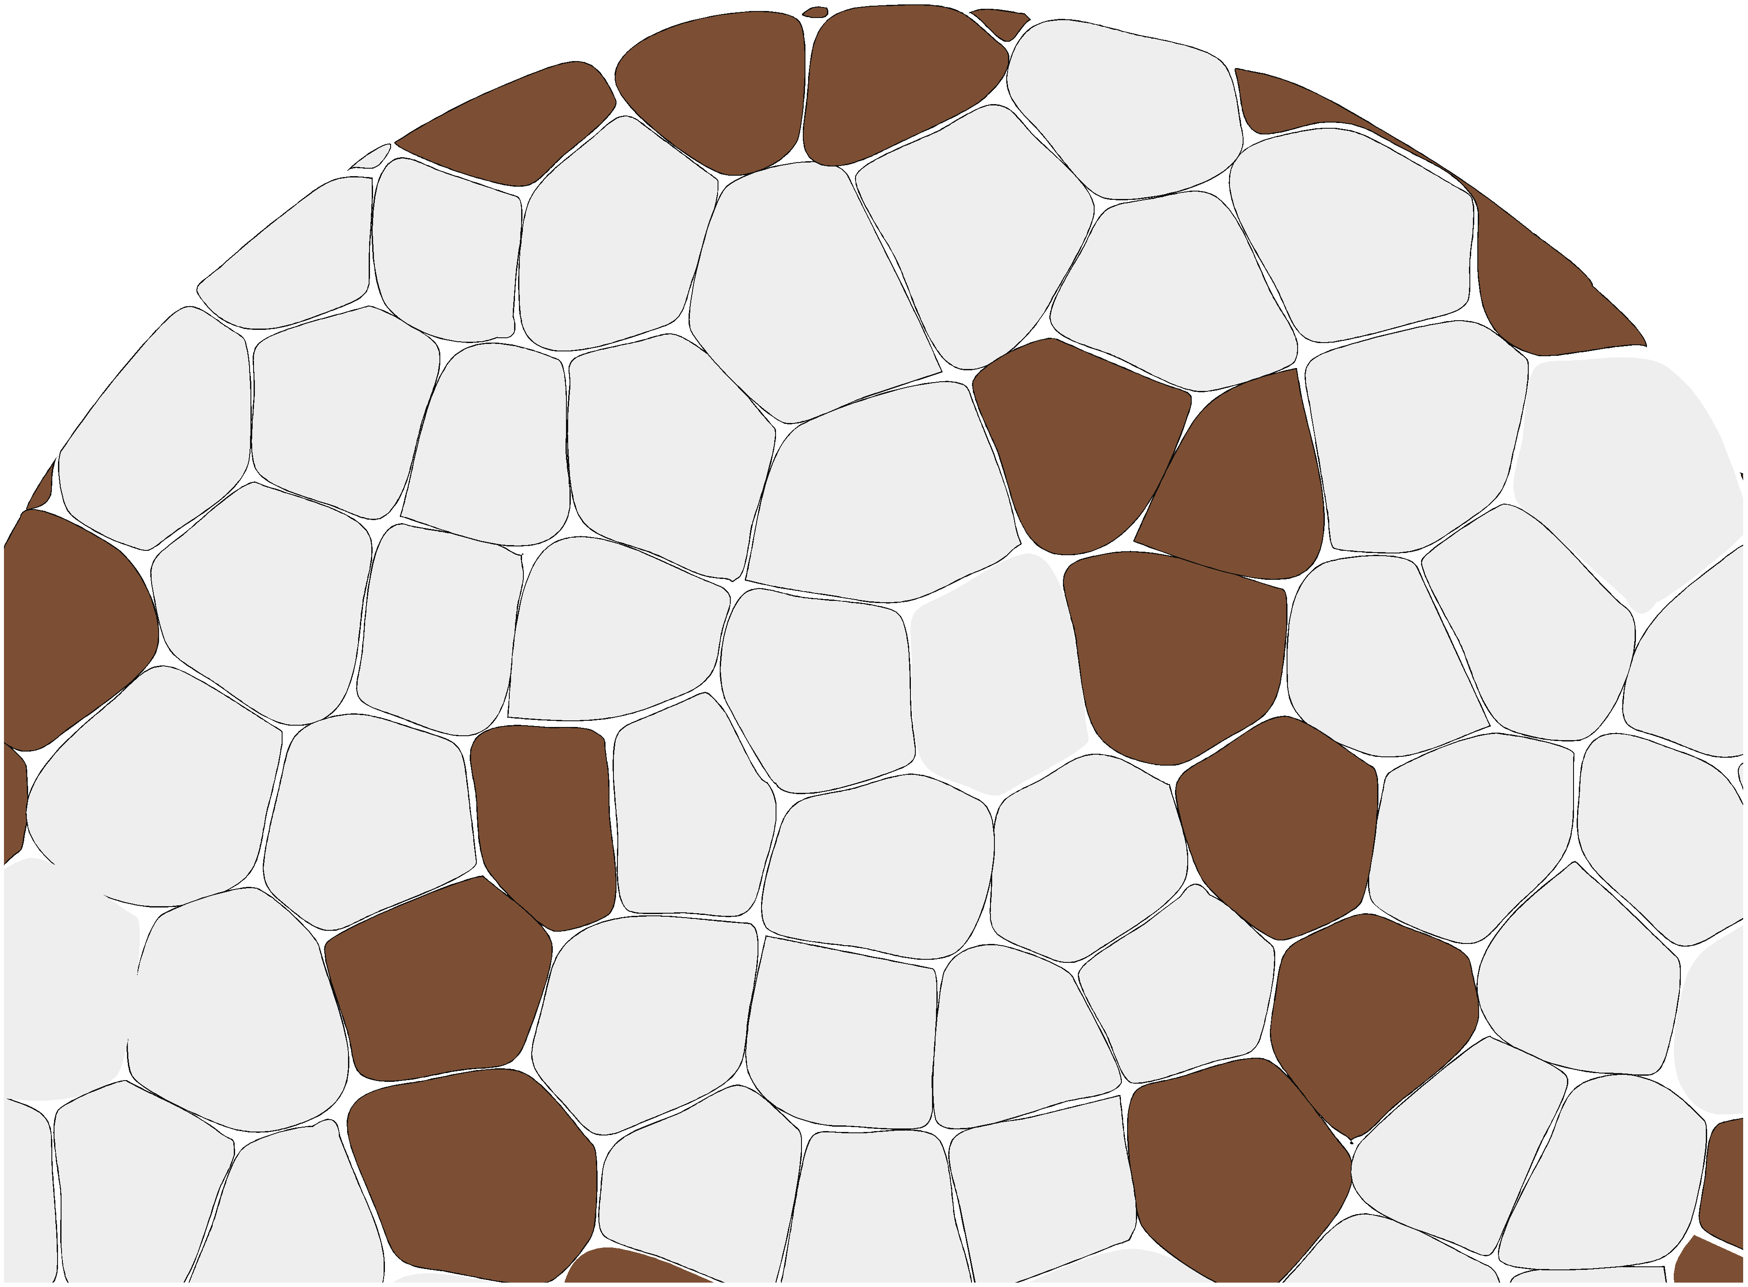

Thanks to the financial support of